**Chapter 5: Introduction to Computer Networks**

**5.1 Basics of Data communication, Data transmission, and Communication modes**

**5.1.1 Data Communication**

The term *telecommunication* means communication at a distance. The word *data* refers to information presented in whatever form is agreed upon by the parties creating and using the data. *Data communications* are the exchange of data between two devices via some form of transmission medium such as a wire cable.

Data communication is the active process of transporting datafrom one point to another. Networks are communication systemsdesigned to convey information from a point of origin to a pointof destination. Note that they are communication systems, not **a** computer systems. The operative word is communication, thetransfer of information from one device to another.

The effectiveness of a data communication system depends onthree fundamental characteristics:

1. Delivery. The system must deliver data to the correct destination. Data must be received by the intended device or user and only by that device or user.
2. Accuracy. The system must deliver the data accurately. Data that have been  
   altered in transmission and left uncorrected are unusable.
3. Timeliness. The system must deliver data in a timely manner. Data delivered late are useless. In the case of video and audio, timely delivery means delivering data as they are produced, in the same order that they are produced, and without significant delay. This kind of delivery is called real-time transmission.
4. Jitter. Jitter refers to the variation in the packet arrival time. It is an uneven delay in the delivery of audio or video packets. For example, let us assume that video packets are sent every 30 ms. If some of the packets arrive with 30-ms delay and others with 40-ms delay, an uneven quality in the video is the result.

**5.1.2 Data Communication Component**

The transmitter sends the message and the receiver receivesthe message. The medium is the channel over which themessage is sent and the protocol is the set of rules that guideshow the data is transmitted from encoding to decoding. Themessage of course is central to all the components. The messageis the data that is being communicated.The following are the basic components for working a communication system.

1. Transmitter (Sender), 2. Receiver, 3. Medium, 4. Message, and 5. Protocol

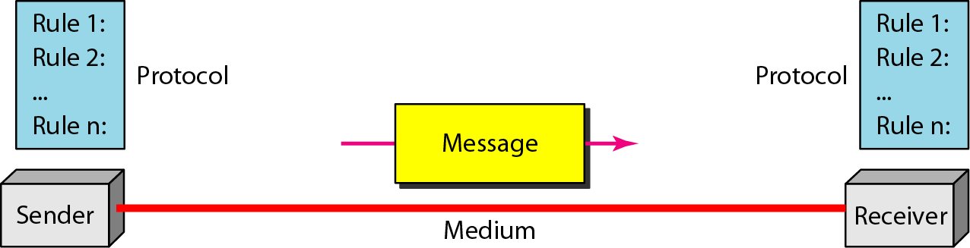

Figure 1: Basic components of communication system

Transmitter: The transmitter is the device that sends the message. It can be a computer, workstation, telephone handset, video camera, and so on.

Receiver: The receiver is the device that receives the message. It can be a computer, workstation, telephone handset, television, and so on.

**Medium**: The transmission medium is the physical path by which a message travels from sender to receiver. It can consist of twisted pair wire, coaxial cable, fiber-optic cable, laser or radio waves (terrestrial or satellite microwave).

**Message**: The message is the transmission (data) to be communicated. It can consist of text, number, pictures, sound, or video or any combination of these.

**Protocol**: A protocol is a set of rules that governs data communication. It represents an agreement between the communicating devices. Without a protocol, two devices may be connected but not communicating, just as a person speaking German cannot be understood by a person who speaks only Japanese.

**5.1.3 Communication Modes**

Communication mode means transferring of data between two devices. Communication between two devices can be simplex, half-duplex, or full-duplex asshown in Figure 2.

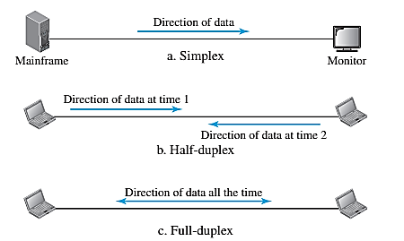

Figure 2: Communication mode

1. **Simplex**

In simplex mode, the communication is unidirectional, as on a one-way street. Only one of the two devices on a link can transmit; the other can only receive (see Figure 2 a). Keyboards and traditional monitors are examples of simplex devices. The keyboard can only introduce input; the monitor can only accept output. The simplex mode can use the entire capacity of the channel to send data in one direction.

1. **Half-Duplex**

In half-duplex mode, each station can both transmit and receive, but not at the same time. When one device is sending, the other can only receive, and vice versa (see Figure 2 b). The half-duplex mode is like a one-lane road with traffic allowed in both directions. When cars are raveling in one direction, cars going the other way must wait. In a half-duplex transmission, the entire capacity of a channel is taken over by whichever of the two devices is transmitting at the time. Walkie-talkies and CB (citizens band) radios are both half-duplex systems.

The half-duplex mode is used in cases where there is no need for communication in both directions at the same time; the entire capacity of the channel can be utilized for each direction.

1. **Full-Duplex**

In full-duplex mode (also called duplex), both stations can transmit and receive simultaneously (see Figure 2 c). The full-duplex mode is like a two-way street with traffic flowing in both directions at the same time. In full-duplex mode, signals going in one direction share the capacity of the link with signals going in the other direction. This sharing can occur in two ways: Either the link must contain two physically separate transmission paths, one for sending and the other for receiving; or the capacity of the channel is divided between signals traveling in both directions.

One common example of full-duplex communication is the *telephone network*. When two people are communicating by a telephone line, both can talk and listen at the same time. The full-duplex mode is used when communication in both directions is required all the time. The capacity of the channel, however, must be divided between the two directions.

**5.2 Computer Networks and Its Application**

**5.2.1** **Computer Networks**

A computer network is the interconnection of various computer systems located at different places. In a computer network, two or more computers are linked together with a medium and data communication devices for the purpose of communicating data and sharing resources. The computer that provides resources to other computers on a network is known as a server. In the network, the individual computers, which access shared network resources, are known as nodes.

**5.2.3 Application of Computer Networks**

* **File sharing**: Network file sharing between computers gives you more flexibility than using floppy drives or Zip drives. Not only can you share photos, music files, and documents, you can also use a home network to save copies of all of your important data on a different computer. Backups are one of the most critical yet overlooked tasks in home networking.
* **Printer / peripheral sharing**: Once a home network is in place, it’s then easy to set up all of the computers to share a single printer. No longer will you need to bounce from one system or another just to print out an email message. Other computer peripherals can be shared similarly such as network scanners, Webcams, and CD burners.
* **Internet connection sharing**: Using a home network, multiple family members can access the Internet simultaneously without having to pay an ISP for multiple accounts. You will notice the Internet connection slows down when several people share it, but broadband Internet can handle the extra load with little trouble.
* **Multi-player games**: Many popular home computer games support LAN mode where friends and family can play together if they have their computers networked.
* **Internet telephone service**: Voice over IP (VoIP) services allows you to make and receive phone calls through your home network across the Internet.

**5.3 Types of Computer Networks**

There are many different types of networks. However, from an end user’s point of view there are three basic types:

* **Local Area Network**
* **Wide Area Network**
* **Metropolitan Area Network**

**5.3.1 Local Area Network (LAN)**

A local area network (LAN) supplies networking capability to a group of computers in close proximity to each other such as in an office building, a school, or a home. A LAN is useful for sharing resources like files, printers, games, or other applications. A LAN in turn often connects to other LANs, and to the Internet or other WAN. Most local area networks are built with relatively inexpensive hardware such as Ethernet cables, network adapters, and hubs. Wireless LAN and other more advanced LAN hardware options also exist. LAN is a computer network that spans a relatively small area.

Most LANs are confined to a single building or group of buildings. However, one LAN can be connected to other LANs over any distance via telephone lines and radio waves. Most LANs (as shown in Fig. 3) connect workstations and personal computers. Each node (individual computer) in a LAN has its own CPU with which it executes programs, but it is also able to access data and devices anywhere on the LAN.

This means that many users can share expensive devices, such as laser printers, as well as data. Users can also use the LAN to communicate with each other, by sending an e-mail or engaging in chat sessions. There are many different types of LANs token ring networks, Ethernets, and ARCnets being the most common for PCs.

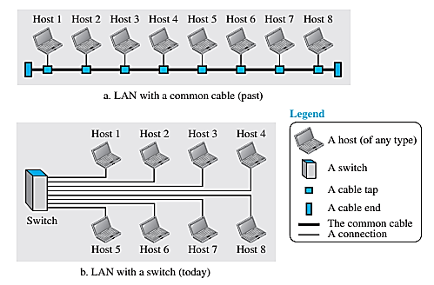

Figure 3: LAN

**5.3.2** Wide Area Networks (WANs)

A wide area network (WAN) is also interconnection of devices capable of communication. However, there are some differences between a LAN and a WAN. A LAN is normally limited in size, spanning an office, a building, or a campus; a WAN has a wider geographical span, spanning a town, a state, a country, or even the world. A LAN interconnects hosts; a WAN interconnects connecting devices such as switches, routers, or modems. A LAN is normally privately owned by the organization that uses it; a WAN is normally created and run by communication companies and leased by an organization that uses it. We see two distinct examples of WANs today: point-to-point WANs and switched WANs.

**Point-to-Point WAN**

A point-to-point WAN is a network that connects two communicating devices through transmission media (cable or air). We will see examples of these WANs when we discuss how to connect the networks to one another. Figure 4 shows an example of a point-to-point WAN.

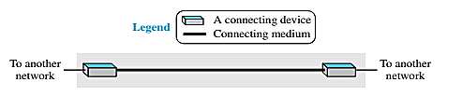

Figure 4: Point to Point WAN

**Switched WAN**

A switched WAN is a network with more than two ends. A switched WAN, as we will see shortly, is used in the backbone of global communication today. We can say that a switched WAN is a combination of several point-to-point WANs that are connected by switches. Figure 5 shows an example of a switched WAN.

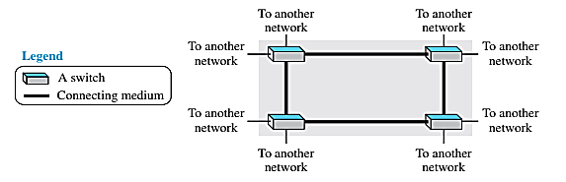

Figure 5: Switched WAN

Today, it is very rare to see a LAN or a WAN in isolation; they are connected to one another. When two or more networks are connected, they make an *internetwork* or *internet*. As an example, assume that an organization has two offices, one on the east coast and the other on the west coast. Each office has a LAN that allows all employees in the office to communicate with each other. To make the communication between employees at different offices possible, the management leases a point-to-point dedicated WAN from a service provider, such as a telephone company, and connects the two LANs. Now the company has an internetwork, or a private internet (with lowercase i). Communication between offices is now possible. 5.3.3 Metropolitan Area Network (MAN)

A Metropolitan Area Network (MAN) is one of a number of types of networks (see also LAN and WAN). A MAN is a relatively new class of network, it serves a role similar to an ISP, but for corporate users with large LANs.

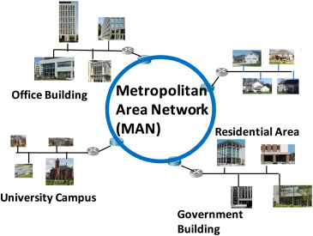

Figure 6: MAN

**5.4.2 Network Models and Topologies**

**5.4.2.1 Network Models**

**What is the OSI model?**

The OSI stands for Open System Interconnection, which was developed in the 1980s. It is a conceptual model used for network communication. It is not implemented entirely, but it is still referenced today. This OSI model consists of seven layers, and each layer is connected to the other. The data moves down the OSI model, and each layer adds additional information. The data moves down until it reaches the last layer of the OSI model. When the data is received at the last layer of the OSI model, then the data is transmitted over the network. Once the data is reached on the other side, then the process will get reversed.

**What is the TCP/IP model?**

The TCP model stands for Transmission Control Protocol, whereas IP stands for Internet Protocol. A number of protocols that make the internet possibly comes under the TCP/IP model. Nowadays, we do not hear the name of the TCP/IP model much, we generally hear the name of the IPv4 or IPv6, but it is still valid. This model consists of 4 layers. Now, we will look at the diagrammatic representation of the TCP/IP model.

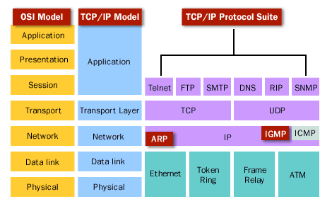

Figure 7: The OSI Model and TCP/IP Model

**5.4.2.2 Network Topology**

Computers in a network have to be connected in some logical manner. The layout pattern of the interconnections between computers in a network is called Network Topology. Some of the network topologies is mentioned below.

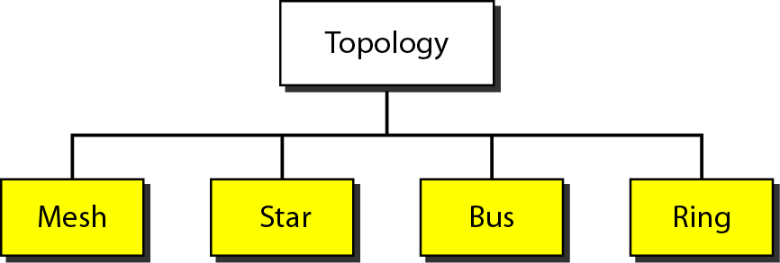

1. **Bus topology**

Uses one main cable to which all nodes are directly connected. The main cable acts as a backbone for the network. One of the computers in the network typically acts as the computer server. The first advantage of bus topology is that it is easy to connect a computer or peripheral device. The second advantage is that the cable requirements are relatively small, resulting in lower costs. One of the disadvantages is that if the main cable breaks, the entire network goes down. This type of network is also difficult to troubleshoot. For these reasons, this type of topology is not used for large networks.

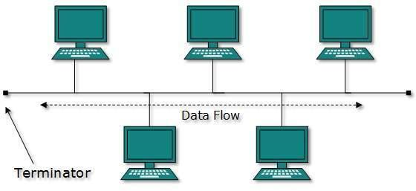

Figure 8: Bus Topology

1. **Star topology**:

In star topology, each computer is connected to a central hub using a point-to-point connection. The central hub can be a computer server that manages the network, or it can be a much simpler device that only makes the connections between computers over the network possible. Star topology is very popular because the startup costs are low. It is also easy to add new nodes to the network. The network is robust in the sense that if one connection between a computer and the hub fails, the other connections remain intact. If the central hub fails, however, the entire network goes down. It also requires more cable than bus topology and is, therefore, more expensive.

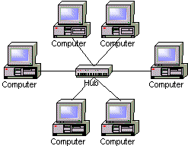

Figure 9: Star Topology

1. **Ring topology:**

In ring topology, the computers in the network are connected in a circular fashion, and the data travels in one direction. Each computer is directly connected to the next computer, forming a single pathway for signals through the network. This type of network is easy to install and manage.

If there is a problem in the network, it is easy to pinpoint which connection is defective. It is also good for handling high-volume traffic over long distances since every computer can act as a booster of the signal. On the downside, adding computers to this type of network is more cumbersome, and if one single computer fails, the entire network goes down.

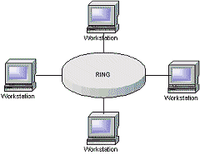

Figure 10: Ring Topology

1. **Mesh topology**:

In a mesh topology, every node has a direct point-to-point connection to every other node. Because all connections are direct, the network can handle very high-volume traffic. It is also robust because if one connection fails, the others remain intact. Security is also high since data travels along a dedicated connection.

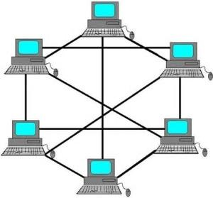

Figure 11: Mesh Topology

**5.4.2.3 Transmission media**

On any network, the various entities must communicate through some form of media. Just as humans can communicate through telephone wires or sound waves in the air, computers can communicate through cables, light, and radio waves. Transmission media enable computers to send and receive messages but do not guarantee that the messages will be understood.

The most common network transmission media are coaxial cable, shielded twisted-pair cable, and unshielded twisted-pair cable, fiber-optic cable, and wireless communications. Select the appropriate media for various situations. Media choices include the following:

* Twisted-pair cable
* Coaxial cable
* Fiber-optic cable
* Wireless communications

Situational elements include the following:

* Cost
* Distance limitations
* Number of nodes

Types of transmission media

There are two categories of transmission media used in computer communications.

1. Bounded media/Guided media
2. Unbounded media/Unguided media
3. **Bounded media:**

Bounded media are the physical links through which signals are confined to narrow paths. These are also called guide media. Bounded media are made up of an external conductor (Usually Copper) bounded by jacket material. Bounded media are great for LABS because they offer high speed, good security, and low cast. However, sometimes they cannot be used due to distance communication. Three common types of bounded media are used in data transmission. These are

* Coaxial Cable
* Twisted Pairs Cable
* Fiber Optics Cable

Coaxial cable

Coaxial cable gets its name because it contains two conductors that are parallel to each other. The center conductor in the cable is usually copper. The copper can be either a solid wire or stranded martial. Outside this central Conductor is a non-conductive material. It is usually white, the plastic material used to separate the inner Conductor from the outer Conductor. The other Conductor is a fine mesh made from Copper. It is used to help shield the cable from EMI.

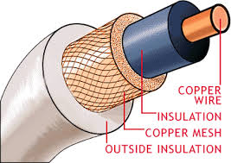

Figure 12: Coaxial Cable

**Twisted Pair Cable**

The most popular network cabling is Twisted pair. It is light weight, easy to install, inexpensive, and support many different types of network. Twisted pair cabling is made of pairs of solid or stranded copper twisted along each other. The twists are done to reduce vulnerability to EMI and cross talk. The number of pairs in the cable depends on the type. There are two types of twisted pair cables:

1. **Unshielded Twisted Pair (UTP)**

It is the most common type of telecommunication when compared with Shielded Twisted Pair Cable which consists of two conductors usually copper, each with its own color plastic insulator. Identification is the reason behind colored plastic insulation. UTP cables consist of 2 or 4 pairs of twisted cables. Cable with 2 pair use RJ-11 connector and 4 pair cable use RJ-45 connector.

1. **Shielded Twisted Pair Cable**

This cable has a metal foil or braided-mesh covering which encases each pair of insulated conductors. Electromagnetic noise penetration is prevented by metal casing. Shielding also eliminates crosstalk. It has same attenuation as unshielded twisted pair. It is faster the unshielded and coaxial cable. It is more expensive than coaxial and unshielded twisted pair.

1. **Fiber Optic Cable**

These are similar to coaxial cable. It uses electric signals to transmit data. At the center is the glass core through which light propagates. In multimode fibers, the core is 50microns, and in single mode fibers, the thickness is 8 to 10 microns. The core in fiber optic cable is surrounded by glass cladding with lower index of refraction as compared to core to keep all the light in core. This is covered with a thin plastic jacket to protect the cladding. The fibers are grouped together in bundles protected by an outer shield.

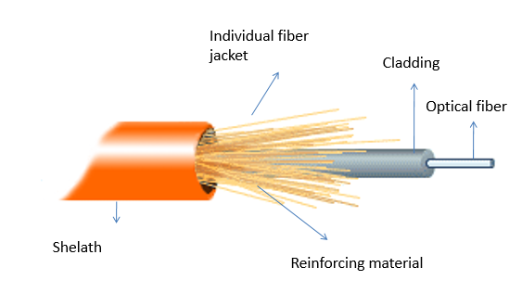

Figure 13: Fiber Optic Cable

1. **Unbounded/Unguided Transmission Media**

Unguided or wireless media sends the data through the air (or water), which is available to anyone who has a device capable of receiving them. Types of unguided/ unbounded media are

* Radio Transmission
* Microwave Transmission

**5.5 The Internet and Web Concepts**

**5.5.1 The Internet**

The Internet is a global system of interconnected computer networks that use the standard Internet protocol suite (TCP/ IP) to serve billions of users worldwide. The most notable internet is called the *Internet* (uppercase I) and is composed of thousands of interconnected networks. It is a network of networks that consists of millions of private, public, academic, business, and government networks, of local to global scope, that are linked by a broad array of electronic, wireless, and optical networking technologies. The Internet carries a vast range of information resources and services, such as the interlinked hypertext documents of the World Wide Web (WWW) and the infrastructure to support electronic mail.

**Internet-Based Services**

Some of the basic services available to Internet users are −

* **Email** − a fast, easy, and inexpensive way to communicate with other Internet users around the world.
* **Telnet** − allows a user to log into a remote computer as though it were a local system.
* **FTP** − allows a user to transfer virtually every kind of file that can be stored on a computer from one Internet-connected computer to another.
* **World Wide Web (WWW)** − A hypertext interface to Internet information resources.

**Limitation of Internet**

* **Theft of Personal information**: Electronic messages sent over the Internet can be easily snooped and tracked, revealing who is talking to whom and what they are talking about. If you use the Internet, your personal information such as your name, address, credit card, bank details, and other information can be accessed by unauthorized persons. If you use a credit card or internet banking for online shopping, then your details can also be ‘stolen’.
* **Negative effects on family communication**: It is generally observed that due to more time spent on Internet, there is a decrease in communication and feeling of togetherness among the family members.
* **Internet addiction**: There is some controversy over whether it is possible to actually be addicted to the Internet or not. Some researchers claim that it is simply people trying to escape their problems in an online world.
* **Children using the Internet**: has become a big concern. Most parents do not realize the dangers involved when their children log onto the Internet. When children talk to others online, they do not realize they could actually be talking to a harmful person. Moreover, pornography is also a very serious issue concerning the Internet, especially when it comes to young children. There are thousands of pornographic sites on the Internet that can be easily found and can be a detriment to letting children use the Internet.
* **Virus threat**: Today, not only are humans getting viruses, but computers are also. Computers are mainly getting these viruses from the Internet. A virus is is a program that disrupts the normal functioning of your computer systems. Computers attached to the internet are more prone to virus attacks and they can end up crashing your whole hard disk.
* **Spamming**: It is often viewed as the act of sending unsolicited emails. This multiple or vast emailing is often compared to mass junk mailings. It needlessly obstructs the entire system. Most spam is commercial advertising, often for dubious products, get-rich-quick schemes, or quasi-legal services. Spam costs the sender very little to send — most of the costs are paid for by the recipient or the carriers rather than by the sender.

**5.5.2 The Web Concepts**

**What is a Website?**

Assume you are currently on the website Google.com which is a collection of various pages written in HTML markup language. This is a location on the web where people can find resources on the latest technologies. Similarly, there are millions of websites available on the web.

Each page available on the website is called a web page and the first page of any website is called the home page for that site.

**What is WWW?**

WWW stands for World Wide Web. A technical definition of the World Wide Web is − All the resources and users on the Internet that are using the Hypertext Transfer Protocol HTTP. A broader definition comes from the organization that Web inventor Tim Berners-Lee helped found, the World Wide Web Consortium W3C: The World Wide Web is the universe of network-accessible information, an embodiment of human knowledge.

In simple terms, *The World Wide Web is a way of exchanging information between computers on the Internet, tying them together into a vast collection of interactive multimedia resources*.

**What is HTTP?**

HTTP stands for Hypertext Transfer Protocol. This is the protocol being used to transfer hypertext documents that make the World Wide Web possible.

A standard web address such as Yahoo.com is called a **URL** and here the prefix HTTP indicates its protocol.

**What is a URL?**

URL stands for **Uniform Resource Locator** and is used to specify addresses on the World Wide Web. A URL is the fundamental network identification for any resource connected to the web.

E.g., Hypertext pages, Images, and Sound files.

A URL will have the following format



The protocol specifies how information is transferred from a link. The protocol used for web resources is HyperText Transfer Protocol HTTP. Other protocols compatible with most web browsers include FTP, telnet, newsgroups, and Gopher.

The protocol is followed by a colon, two slashes, and then the domain name. The domain name is the computer on which the resource is located.

Links to particular files or subdirectories may be further specified after the domain name. The directory names are separated by single forward slashes.

**What is a Web Server?**

Every Website sits on a computer known as a Web server. This server is always connected to the *Internet*. Every Web server that is connected to the Internet is given a unique address made up of a series of four numbers between 0 and 256 separated by periods. For example, 68.178.157.132 or 68.122.35.127.

When you register a Web address, also known as a domain name, such as Google.com you have to specify the IP address of the Web server that will host the site.

**What is a Web Browser?**

Web Browsers are software installed on your PC. To access the Web you need web browsers, such as Netscape Navigator, Microsoft Internet Explorer, or Mozilla Firefox.

**What is SMTP Server?**

SMTP stands for Simple Mail Transfer Protocol Server. This server takes care of delivering emails from one server to another server. When you send an email to an email address, it is delivered to its recipient by an SMTP Server.

**What is ISP?**

ISP stands for Internet Service Provider. They are the companies who provide you service in terms of internet connection to connect to the internet. You will buy space on a Web Server from any Internet Service Provider. This space will be used to host your Website.